PRACTICAL FILE

BE (CSE) 6th Semester
COMPILER DESIGN
Submitted By
Rohit Kumar Singh
Roll Number: UE203093

Submitted To
Prof. Harsh Ahlawat

Computer Science and Engineering
University Institute of Engineering and Technology
Panjab University, Chandigarh – 160014, INDIA
2022
Program 4. Lex Programs

AIM:
To implement various LEX programs.

Learning Objectives:
To be familiar with various LEX programs..

List of Programs:
1. To swap uppercase with lowercase letters and vice versa.
2. Program to find the number of words.
3. To add line numbers at the start of each line.
4. Check the valid Phone Number.
5. WAP to count words greater than 5 and truncate the rest of the portion.

Theory:
LEX is a popular tool for generating lexical analyzers for programming languages. LEX programs are used to recognize and convert the input source code into a stream of tokens, which are meaningful units of the programming language.

A LEX program consists of a set of rules, where each rule defines a pattern to be matched and an action to be taken if the pattern is found. The patterns are specified using regular expressions, and the actions are arbitrary C code that performs the necessary processing.

To use LEX, the programmer typically defines the set of regular expressions and corresponding actions for each token, and then compiles the LEX program into a C program. The resulting C program can then be compiled and linked with the parser or interpreter to create a complete system for processing the source code.

LEX programs are widely used in the development of compilers and interpreters for programming languages, as well as in other applications that require pattern recognition, such as text processing and data analysis. They provide a powerful and flexible mechanism for recognizing and processing input streams based on regular expressions, and can greatly simplify the task of writing lexical analyzers for complex programming languages.

Generic LEX program:
/* LEX program to recognize and convert input source code to tokens */

%{
/* Declarations and code to be included in the generated C code */
#include <stdio.h>
#include <stdlib.h>
%}

/* Regular expression patterns and corresponding actions */
%%
"int" { printf("INT\n"); }
"float" { printf("FLOAT\n"); }
. { printf("ERROR\n"); } /* Handle unknown tokens */
%%

/* Additional C code to be included in the generated C code */
int main(int argc, char **argv)
{
yylex(); /* Call the generated yylex() function to process the input */
return 0;
}

Program 1: To swap uppercase with lowercase letters and vice versa.

%{
#include <iostream>
#include <string>
using namespace std;
%}

%%
[a-z] {cout << char(yytext[0]-32);}
[A-Z] {cout << char(yytext[0]+32);}
. {cout << yytext;}
%%

int main(void) {
yylex();
return 0;
}

int yywrap() {
return 1;
}

Output:
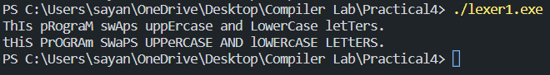

Program 2: Program to find the number of words.

%{
#include <iostream>
#include <string>
using namespace std;

int words = 0;
void end_of_input() {
cout << "Number of words = " << words << endl;
}
%}

%%
[ \t]+ {}
[a-zA-Z0-9]+ {words++;}
[\n] {end_of_input();}
%%

int main(void) {
yylex();
return 0;
}

int yywrap() {
return 1;
}

Output:
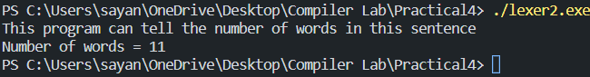

Program 3: To add line numbers at the start of each line.

%{
#include <iostream>
#include <string>
using namespace std;

int lineNumber = 1;
string line = "";
%}

%%
[^\n] {line += yytext;}
[\n] {cout << "(" << lineNumber << ") " << line << endl; line = ""; lineNumber++; }
%%

int main(void) {
yylex();
return 0;
}

int yywrap() {
return 1;
}

Output:
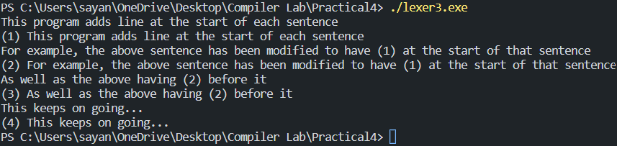

Program 4: Check the valid Phone Number.

%{
#include <iostream>
#include <string>
using namespace std;
%}

%%
[+][0-9]{2}[0-9]{10} {cout << "Matched";}
.* {cout << "Not Matched";}
%%

int main(void) {
yylex();
return 0;
}

int yywrap() {
return 1;
}

Output:
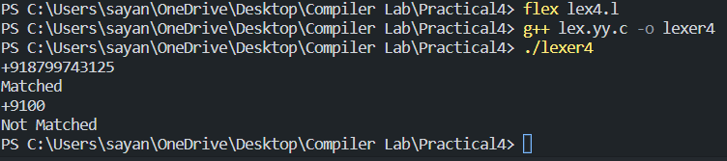

Program 5: WAP to count words greater than 5 and truncate the rest of the portion.

%{
#include <iostream>
#include <string>
#include <vector>
using namespace std;

vector<string> v;
%}

%%
[a-zA-Z0-9]{6,} {v.push_back(yytext);}
[\n] {cout << "There are " << v.size() << " words greater than five characters. The words are: \n"; for(auto &i: v) cout << i << endl; cout << "The words after truncation are: \n"; for(auto &i: v) cout << i.substr(0, 5) << endl;}
[a-zA-Z0-9]+ {;}
. {;}
%%

int main(int argc, char **argv)
{
yylex();
return 0;
}

int yywrap() {
return 1;
}

Output:
